September 2015
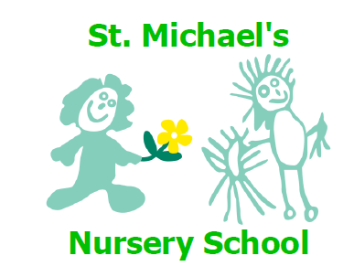

Welcome to a new term at St Michael’s nursery school. Everyone is very excited at the prospect of starting nursery and we will all work in close partnership with you the parents to make this transition as smooth and stress free as possible.
We will be spending time over the next few weeks helping your child settle into the nursery. We do this by providing consistency of routines and familiar activities.
We will learn the Golden Rules of nursery daily so your child has a clear understanding of what is expected of them. Copies of the Golden Rules are displayed in our hallway for your information.

Our topic this month is nursery rhymes and emotions and you can see examples of what we will be doing in each of the curricular areas displayed in the front hallway.
Your child has received a copy of “Sing along with Harper” This beautiful book and CD has been provided by West Belfast Partnership Board and features nursery rhymes for you to share with your child at home.
General house keeping.
Nursery fund
Envelopes for payment of nursery fund @£3.00/wk will be issued 2 times a term. We appreciate your prompt payment in the envelope provided.
Dinners

As our dinner routines are due to commence in October I would ask everyone to make their payment of £2.40/day on a Monday returned in the envelope provided .
Controlled access.
In the interests of the children’s safety the door is locked every morning at 9.00am. In order to limit interruption in Mrs Mc Allister’s class it is important that your child is in school before 9.00am.

Car park
Car parking is limited and is used to facilitate staff and disabled drivers only. I would appreciate that parents do not use the car park in the interests of safety for all.
Labelling uniform

It is essential that we can identify your child’s new uniform. Please ensure that all items are clearly marked with your child’s name.

Our website will be updated regularly with communications diary updates and photographs of your child at play. Notifications of new information will be posted on the white board in the nursery hallway.
We are all looking forward to a year of close partnership and a fun filled learning experience for your children.

